Preparation
Students will prepare a Scenario Performance of no more than 5 minutes in length. This storytelling presentation should focus on a logical outgrowth of actions or events related to one of the annual topics. As in other Future Problem Solving components, research on their chosen topic will be very helpful as competitors prepare their performance.
Students may use a maximum of 10 cue cards during their performance. Performers are not permitted to wear clothing that identifies any Affiliate Program. Theatrical makeup or costumes are inappropriate for Scenario Performance. Students should prepare their stories to be recorded by a fixed camera. They may stand or sit in a chair/stool for performances.
Before submission, coaches should remind their students of the following:
- Performances must show a recognizable relationship to one of the topics for the current FPS year
- Recorded Performances must be one continuous take with no edits
- Performances must be labeled and titled as directed by the Affiliate Program
PLEASE NOTE: Late or incorrectly formatted/submitted entries will be evaluated, but may not be eligible for awards.

Submission
Coaches were provided with instructions for coding/titling/labeling their Performances by their Affiliate Program. At the time of submission, competitors will provide:
- Competitor name
- Coach name and email
- School
- Division
- Brief summary of Performance, including a clear link to the topic
- Competitor Code
- Publication Release and Statement of Authenticity (uploaded as a PDF)
- Link to the Performance as an unlisted YouTube video
Submission Procedures:
- At the beginning of the recording, the student should hold up a card/paper with their competition code as an identifier before starting the Performance. This is not included in the 5-minute time limit.
- The recording must be continuous, with no cuts, edits, or movements of the camera location.
- The focus must remain constant with the camera focusing on either the head-and-shoulders or the full-body of the Scenario Performer, sitting or standing.
- The location of the Scenario Performance is left to the discretion of the storyteller.
- To make conversion to an unlisted YouTube video easier, the Scenario Performance is best captured as an MP4 digital video file, using the student competition code as the file name. Play the file before submission to ensure that is has been captured and plays properly.
- The video file must be uploaded to YouTube as an unlisted link. For guidance on the upload process, please see the next section of this document.
- There must be no identifying information in the performance, including the competitor’s name or the names of their school, Affiliate, country, state, etc. This includes clothing that students wear during their Performance.

Uploading an unlisted video on YouTube

To create an unlisted YouTube video, you will need a YouTube account. You must upload your video as an unlisted video so that it is not accessible publicly on YouTube. Here are the steps to create this type of video:
- Sign into your YouTube account and in the upper right corner of the screen you will see a camera with a plus sign – the “Create” icon. Click it, then select “Upload Video.”
1.

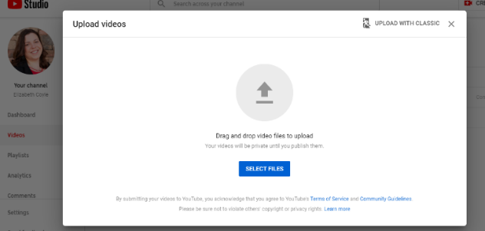
- This will bring you to a page that says, “Studio”, and give you the option to either drag and drop, or select a file to be uploaded.
2.

- On the next screen, give your video a title and description. Do not identify the student/school by name in either title or description. Use the code provided to you as both title and description (i.e. PJ-1501, etc.) Then, scroll down and select “Made for Kids.” Click, “Next.”

- You’ve reached the Video Elements screen. There is nothing to select here (it is grayed out due to the video being, “Made for Kids”), just click, “Next” on the bottom right of the screen.

- You’ve reached the Visibility page. Select “Unlisted.”

- Now click, “Save” in the bottom right of the screen, and you’ve uploaded your video!

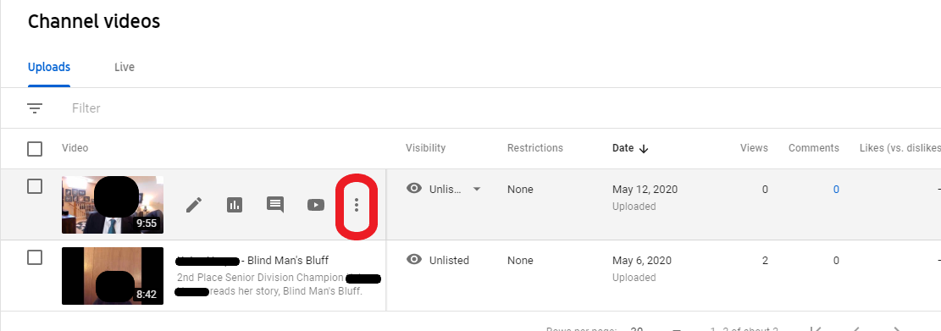
- To get the direct link to your video, roll your mouse over the video. You will see a few icons, with 3 vertical dots on the right. Click those, then click, “Get shareable link.” This will copy the video’s link. This is the link to be submitted within FPSOnline.
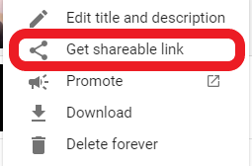
7.

